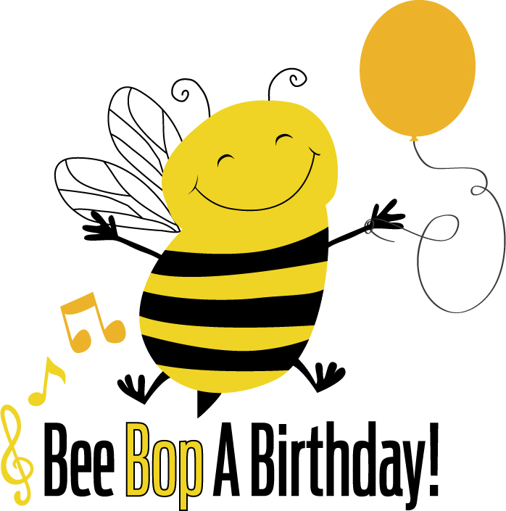

You are invited to a Bee Bop A Birthday party on

The venue and start time are as follows

Please RSVP to ________________
Optional fancy dress
www.beebopabirthday.co.uk

